**Mock-up**

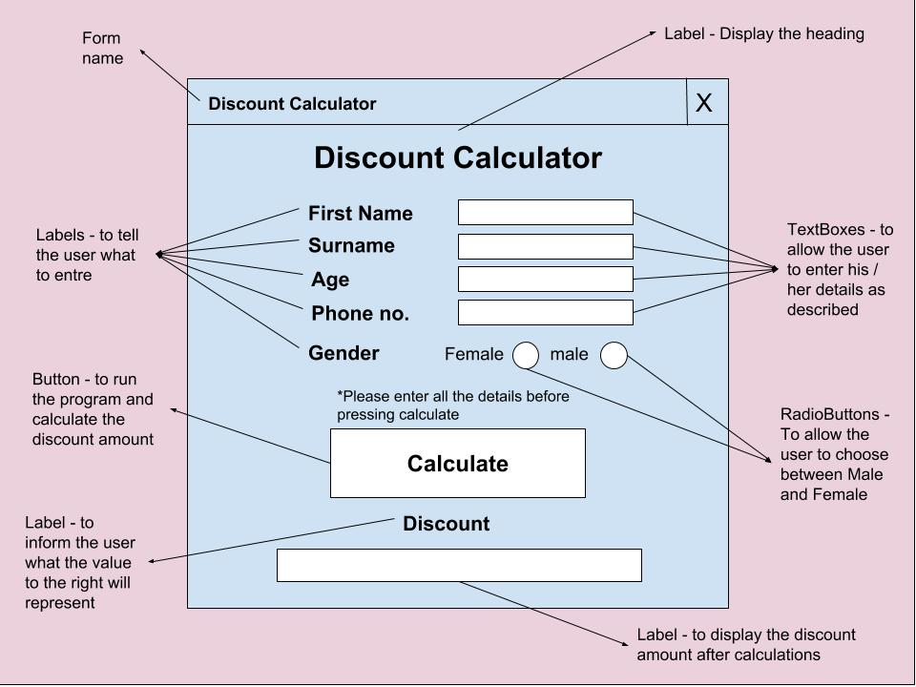

**Data Dictionary**

|  |  |  |  |
| --- | --- | --- | --- |
| **Name** | **Purpose** | **Data type** | **size** |
| FirstName | To store the user’s first name | String | 10 - 15 |
| SurName | To store the user’s surname | String | 10 - 15 |
| Age | To store the user’s age | String | 10 |
| PhoneNum | To store the user’s phone number | String | 10 |
| Gender | To store the user’s gender – weather a Male or a Female | Public String | - |
| DiscountAge | To store the amount of discount after checking age – if there is one | Integer | 2 |
| DiscountFemale | To store the amount of discount after checking for female | Integer | 2 |
| DiscountAmount | To store the discount amount – if there is one – The sum of DiscountAge and DiscountFemale | Public Integer | 2 |

**Object Description**

|  |  |  |  |  |
| --- | --- | --- | --- | --- |
| **Name** | **Type** | **Purpose** | **Attached Method** | **Format** |
| FirstNameTextBox | Text Box | To allow the user to enter their first name | - | Font: Microsoft Sans Serif – Bold – 11  Justification: Centre  Visible: Yes  Font Colour: Black |
| SurNameTextBox | Text Box | To allow the user to enter their surname |  | // |
| AgeTextBox | Text Box | To allow the user to enter their Age | - | // |
| PhoneNumTextBox | Text Box | To allow the user to enter their phone number | - | // |
| FemaleRadioBtn & MaleRadioBtn | Radio Button | To allow the user to choose between female or male | - | Visible: Yes  Fore Colour: White |
| FNLabel, SNLabel, AgeLabel, PNLabel, GenderLabel | Label | To inform the user of what to enter in the text box next to them – or (for GenderLabel) to choose from the two options | - | Font: Microsoft Sans Serif – Bold – 11  Justification: Centre  Visible: Yes  Font Colour: Black |
| CalcBtn | Button | To run the program | Calculate() | Visible: Yes  Font Colour: Black |
| DiscountHeadingLabel | Label | To inform the user of what the number to the right will represent | - | Font: Microsoft Sans Serif – Bold – 11  Justification: Centre  Visible: Yes  Font Colour: Black |
| DiscountLabel | Label | To display the discount message | - | // |

**Pseudocode**

Create a public string variable called Gender

Create a public string variable called DiscountAmount

**CalcBtn_Click**

**Begin**

Calculate()

**End**

Caluclate()

**Begin**

**Get** FirstName, SurName, Age, PhoneNum

DiscountAge ← 0

DiscountFemale ← 0

**If** FemaleRadioBtn is Checked **Then**

Gender 🡨 “Female”

**ElseIf** MaleRadioBtn is Checked **Then**

Gender ← “Male”

**EndIf**

**If** Age > 65 **OR** Age < 18 **Then**

DiscountAge ← 15

**EndIf**

**If** Gender = Female **Then**

DiscountFemale ← 10

**EndIf**

DiscountAmount ← DiscountAge + DiscountFemale

DiscountLabel ← “Hello” + FirstName + “ “ + SurName + “You’re phone number is “ + PhoneNum + “You got a discount of “ + DiscountAmount + “%”

**End**